Creating Azure Virtual Machine (VM)

# Steps:

1. **Sign in to Azure Portal**:
   * Go to the Azure portal and sign in with your Azure account credentials.

1. **Navigate to Virtual Machines**:
   * In the left-hand menu, select “Virtual machines” or use the search bar at the top to find it.

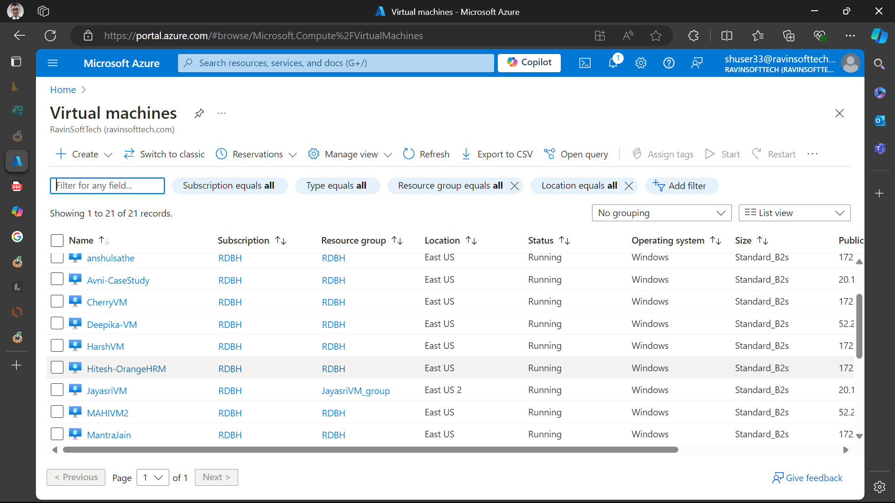

1. **Create a New VM**:
   * Click on the “Create” button and then select “Azure virtual machine”.

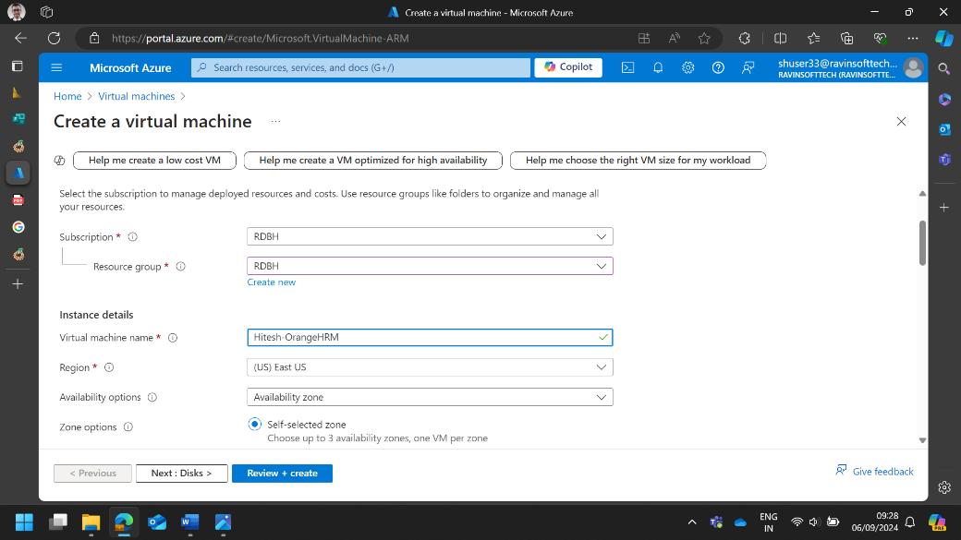

1. **Configure Basic Settings**:
   * **Subscription**: Choose your Azure subscription.
   * **Resource Group**: Select an existing resource group or create a new one.
   * **Virtual Machine Name**: Enter a name for your VM.
   * **Region**: Choose the region where you want to deploy the VM.
   * **Availability Options**: Select availability options if needed.
   * **Image**: Choose the operating system image (e.g., Windows Server, Ubuntu).
   * **Size**: Select the VM size based on your requirements.

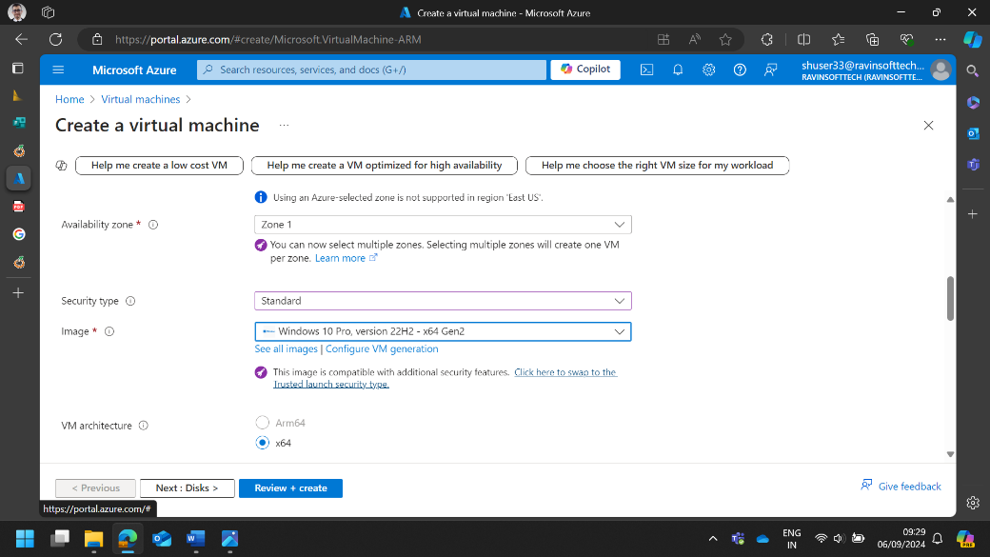

1. **Administrator Account**:
   * **Username**: Enter a username for the VM.
   * **Password**: Create a strong password.

1. **Inbound Port Rules**:
   * Allow necessary ports (e.g., RDP for Windows, SSH for Linux).

1. **Disks**:
   * Choose the OS disk type (Standard HDD, Premium SSD, etc.).
   * Add any additional data disks if required.

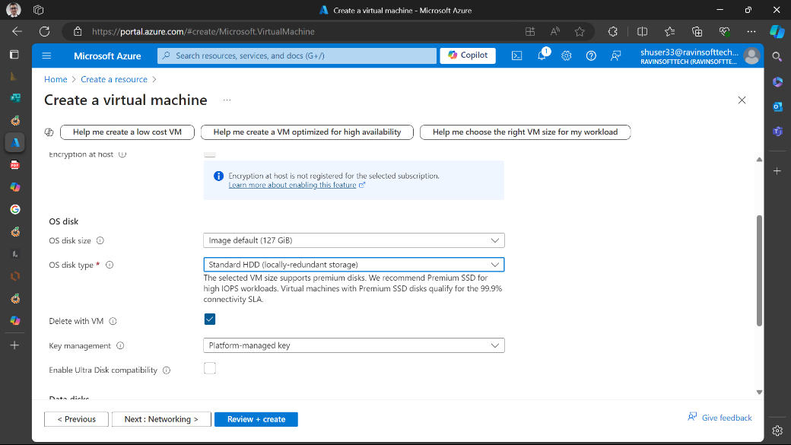

1. **Networking**:
   * Configure the virtual network, subnet, public IP, and network security group settings.

1. **Review + Create**:
   * Review all the settings and click on the “Review + create” button.
   * After validation, click on the “Create” button to start the deployment.

1. **Connect to the VM**:
   * Once the VM is deployed, go to the VM resource page.
   * Click on “Connect” and choose the connection method (RDP for Windows, SSH for Linux).
   * Download the RDP file or use SSH to connect to your VM.

